Champlain College

Week 4: Assignment: Personal Learning Journal  
(#4)

Paul Sherwood

1146080

MBA-506-81: Project Management

1 February 2025

Helen Tanona

The purpose of this paper is to describe a project that I was a part of and describe where the project struggled. Over four years ago, I was blessed to be a part of a project to create a Flight Training Device (FTD) that would replace my company's current cardboard version of an FTD with one that gives user feedback similar to a real aircraft. I want to say that I had zero issues while the project was going on, but as we have seen in our reading, there isn’t a project that does not come with some problems during the duration of the project.

The FTD was originally imagined as XPlane11 pushed to some touch screens. As we moved forward, we found limitations in the current setup and were forced to look for solutions. For example, the lower console was unusable as the buttons were offset from the original view. Which came from having one XPlane stretched over five or so monitors. My role in this project was to lead it. I would assign tasks to different people, such as one person for purchasing, one person for electronics, and one person for hardware setup.

The budget was planned for $6,000. I am happy to report we met that goal with plenty of leeway. To focus on cost-cutting, we searched for open-source code and software. After finding the open-source software that would do our lowest console and discarding other paid projects, we had to alter many parts of the code. It was designed with XPlane in mind, but the code was written to only show certain items. We altered the code to work on the FTD and the now-realized desktop trainer we created.

To be fair, the $6,000 was a guesstimate. I knew that we could do most of the software for free, so the bulk of the cost would be in the hardware. With one of the techs being extremely creative, we were able to purchase all of our hardware at about $3,000. This is to include parts that were trial and error or that we couldn’t use for this project. I didn’t use a WBS I had to rely on my own experience to get these numbers.

In the reading, they said, "Less experienced managers who are required to make analogous estimates can look through the documentation that is available from previous projects." (Darnall, 2010) My case was something similar: everyone who had the potential to work on the project pitched in during the discussion to come to an agreed number. It is hard to say if we were accurate in our estimate. My thinking was that what we came up with should not be the number presented; I know there could be cost overruns, and we need room to find solutions.

I can say that when we were all done, everyone was happy, and we were under budget. It was the most successful project I have been a part of. I will say that I did have a top-down in the back of my head; I knew the order in which we had to complete certain tasks. I felt time-constrained, so we worked every possible minute while not needed for our normal maintenance jobs. Given the situation I was in, I don’t think a proper WBS would have meant anything. Also, I didn’t know what a WBS was at the time. It sure looked clean when we were done.

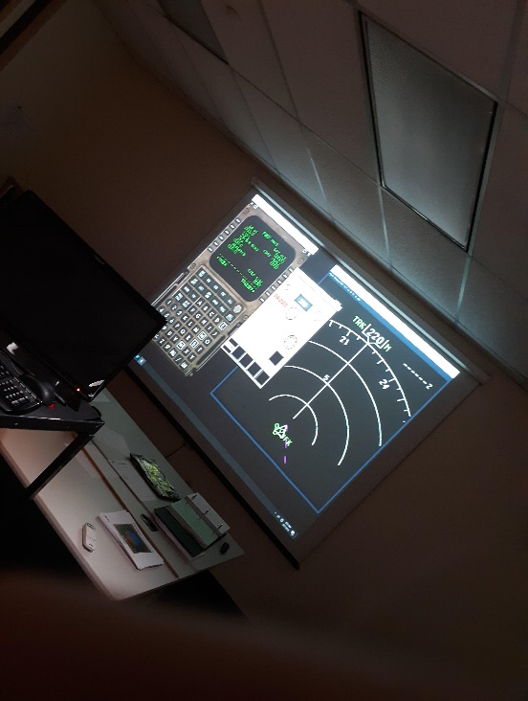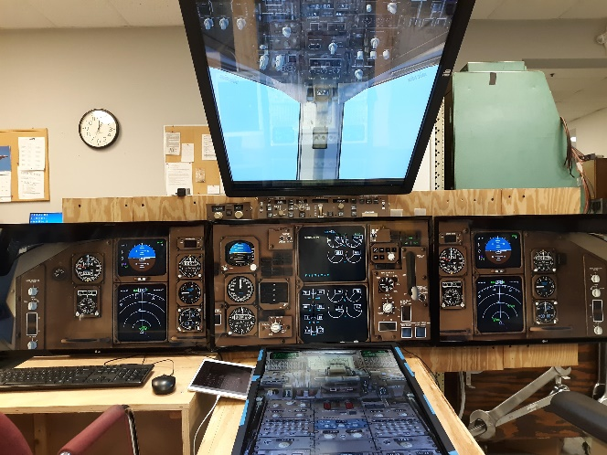

References:

Darnall, R., & Preston, J. (2010). Project management from simple to complex. Retrieved from https://www.opentextbooks.org.hk/system/files/export/38/38453/pdf/Project_Management_from_Simple_to_Complex_38453.pdf